**Existing Scheduling System**

Currently, due to the Airline Deregulation act of 1978, the scheduling of flights is determined by market forces, airline decisions, and airport-determined rules for how slots can and cannot be used. In this system, airports offer slots to airlines, which set a maximum on airline service may be bounded by number of flights, or number of passengers. IATA’s Worldwide Slot Guidelines (WSG) also play a guiding role in determination of an airport’s slot policy [1].  
 In this framework, slots are distributed to airlines according to legal procedures and expected demand for each airline, and the airlines then schedule their flights in accordance with those allocations. Because of this, large and high capacity airlines are incentivized, making market entry for smaller airlines difficult. Generally, slots dictate how many gates are available as well so that slot policy, coupled with gate leases, makes for a very calcified and profit focused market at large, busy airports such as LAX. Furthermore, since both airlines and airports are competitors, there is often little to no communication between parties, leading to a schedule that may be optimal for each entity, but is not efficient globally, leading to conflicts and delays.  
 Though this practice leads to an inefficient and highly profit driven policy under the current paradigm, slots can be as restrictive as they need to be. This means airport slot policy could be a possible area of improvement or regulation to implement a more delay optimized schedule.

**Approach**

To approach a problem such as this with its high potential for political and economic impacts throughout the air traffic industry, our group determined that the primary issue in developing effective regulation was the information gap it would have to overcome. The decisions of passengers, airlines, and airports are influenced by a plethora of factors. Thus, to determine a schedule that could reduce delays, as much data as possible should be taken into account to accurately predict the effects of making such changes to avoid regulation inefficiencies due to a lack of information.  
 To address this problem, our project focuses on investigating and experimenting with different optimization techniques to demonstrate the merits of developing scheduling software that uses individual flight data to produce a delay-minimizing schedule and assess its impact on the air transportation industry of Los Angeles. Research into this topic throughout the semester yielded two promising methods: Mixed Integer Linear Programming (or MILP for short) and Dynamic Programming. Both have been used by previous work in the field of air traffic scheduling and can be applied to optimize a variety of factors [3] [4]. Computational methods are also widely used by the FAA to assist air traffic controllers, such as in the case of the Center TRACON Automation System (CTAS) used to schedule aircraft and maintain safe spacing [2]. Our problem expands upon this work with the added complexity of scheduling between multiple airports as options and minimizes delays where as others focus on maximizing aircraft separation.

**MILP**

At their core, MILPs are simply linear programs that utilize branch and bound to derive integer solutions and often apply the Big M Method to transform logical disjunctions into constraints that can be analyzed by a linear solver. Its benefits include its relative ease of implementation and flexibility in making changes or improvements later since the whole program depends mainly on changes to the constraint matricies. However, early results showed that MILPs of this variety are inherently time intensive, as its number of constraints and variables can easily balloon into the millions with less than a single day of arrivals to schedule.  
 Because of this, a set of assumptions had to be proposed and validated to make the problem feasible and the scope of the project had to be scaled back from arrivals and departures to just arrivals. Even with these assumptions though, the MILP suffers from an unpredictable time complexity that becomes infeasibly long in scenarios with difficult to locate optimums. Despite these flaws, the MILP remained the simplest to change and experiment with, and was selected as our method of choice to go ahead with further refinements.  
 Air traffic, with its many regulations and technical constraints, requires a properly posed problem to accurately represent real conditions. The below figure shows a summary of the problem’s components and how they were represented mathematically. Initially the problem was designed with the capability of determining the amount of holds and route delay that would be required to achieve an optimal distribution, providing further guidance for air traffic control decisions, but this added layer of detail was determined superfluous and a drain on resources. It was kept, but disabled to improve run time.   
 The other critical factors modeled by this problem are a delay limit to prevent any one aircraft from being forced to endure excessive delays and the objective function, which defines delay as the difference between scheduled arrival time and the earliest possible time that aircraft could arrive with an unimpeded approach.

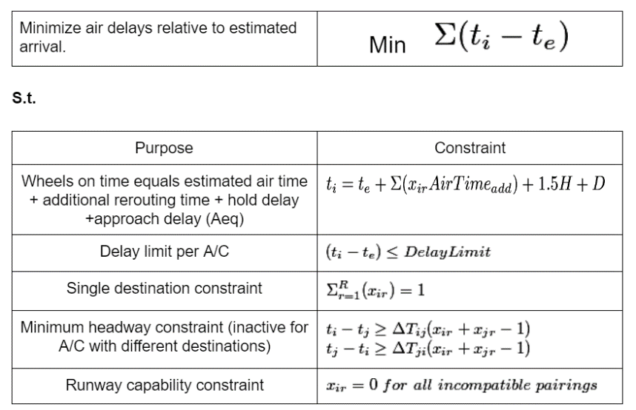

In MATLAB, the following four steps detail the process for solving this problem given our available data.

1. Individual flight data is extracted from ASPM database
2. Aircraft equipment ID and other databases are used to determine: ➤ weight category ➤ fuel consumption  
   ➤ point of origin ➤ original destination,   
   ➤ separation requirements ➤ time impacts of changing destination
3. For loops assemble the constraint arrays A, B, Aeq, and beq from the data calculated in Step 2
4. Intlinprog function uses the simplex algorithm and branch and bound to explore options and find a delay minimizing schedule

**Assumptions**

**Constraint Selection/Bivariate Constraint Selection**

Beyond physical constraints, optimality conditions must also be taken into account, and tolerances on solutions and variables can be relaxed to improve time complexity in some large sample size scenarios.

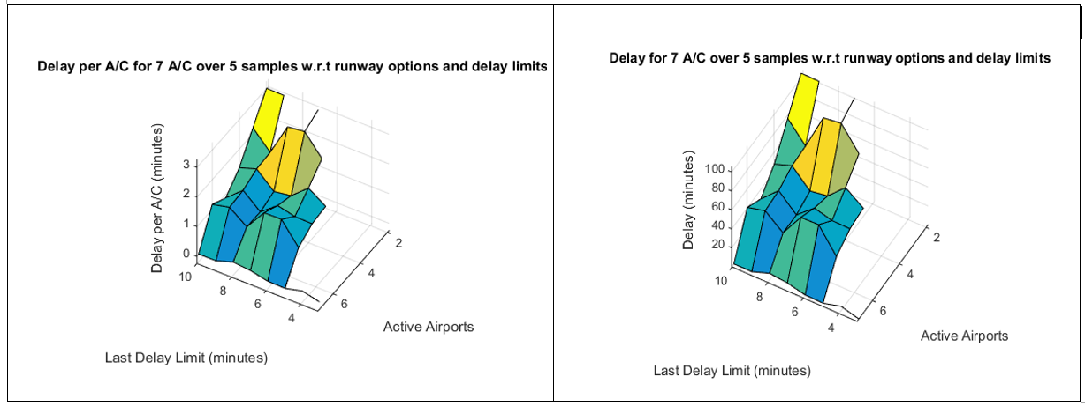

**Results**



200 flights

5.5 minutes of delay total

7 minute excess scheduling window

5 iterations of 40 A/C, starting at 9:00, the typical beginning of peak hour.

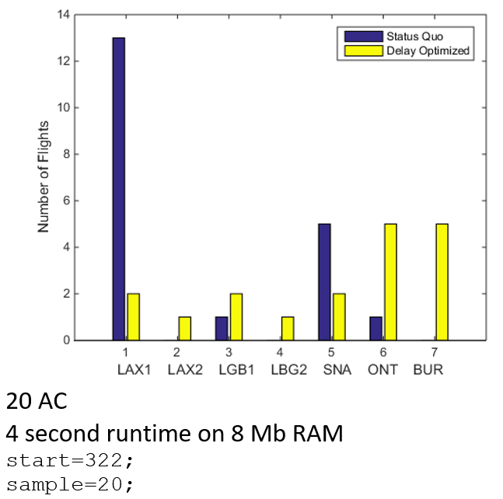

**Issues and Improvements**

**Dynamic Programming**

**Swarm Optimization**

**Economic Analysis – Issues in implementation (unforeseen lack of data)**

**Future Improvements – Impact of off airport transit**

**Computational Conclusions**

**Works Referenced**

[1] <http://www.iata.org/policy/infrastructure/slots/Pages/index.aspx>

[2] <http://bayen.eecs.berkeley.edu/sites/default/files/conferences/MILP_formulation.pdf>

[3] http://bayen.eecs.berkeley.edu/sites/default/files/conferences/real-time_discrete_control_law_synthesis.pdf

[4] <http://bayen.eecs.berkeley.edu/sites/default/files/conferences/gnc04.pdf>